**LAB # 01**

**INTRODUCTION TO STRING POOL, LITERALS, AND WRAPPER CLASSES**

**LAB TASKS**

1. Write a program that initialize five different strings using all the above mentioned ways, i.e.,

a) string literals

b) new keyword

also use intern method and show string immutability.

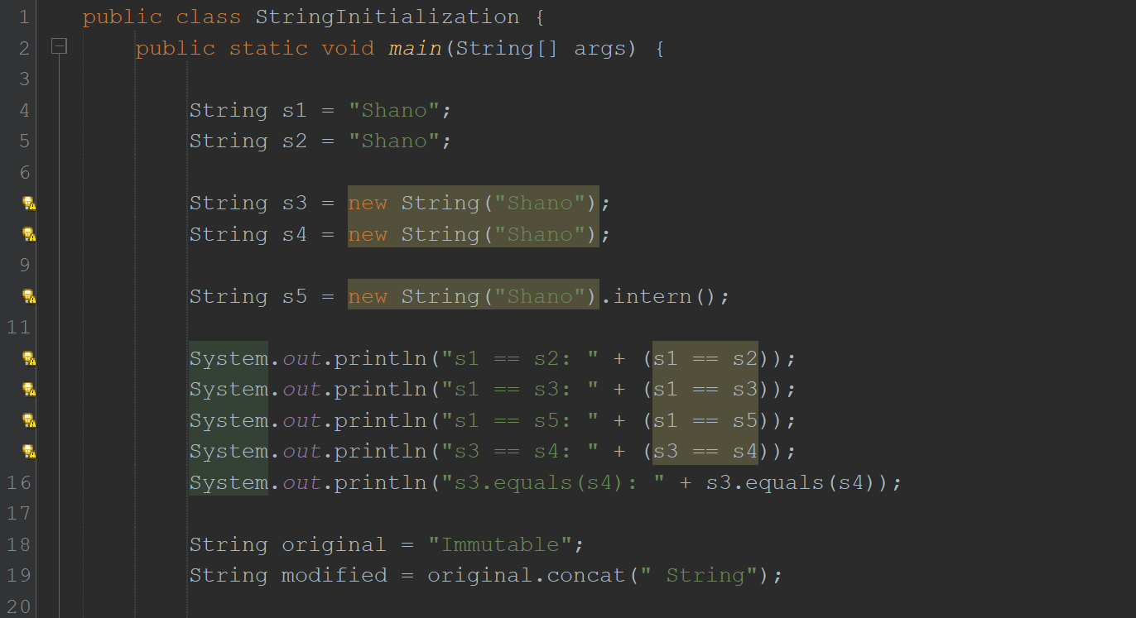

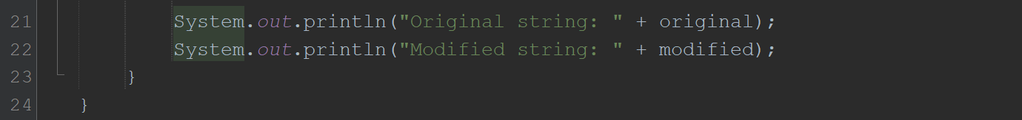

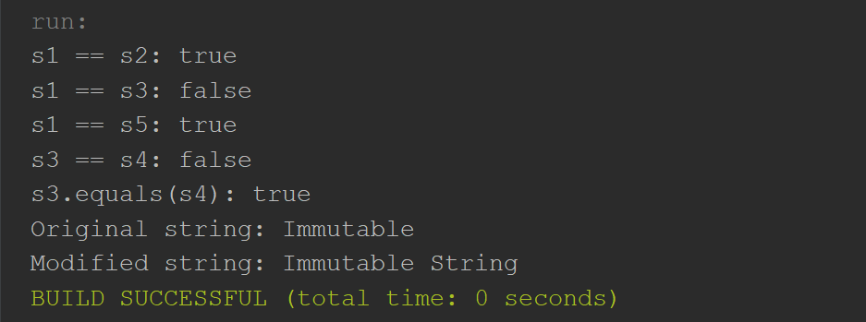

2. Write a program to convert primitive data type Double into its respective wrapper object.

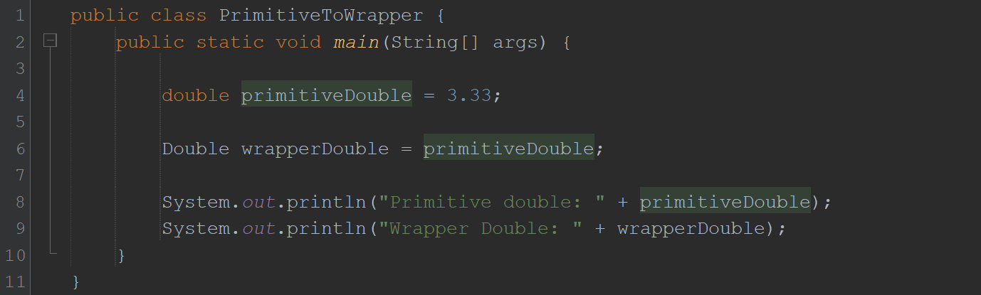

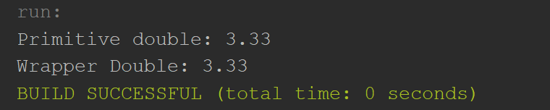

3. Write a program that initialize five different strings and perform the following operations.

a. Concatenate all five stings.

b. Convert fourth string to uppercase.

c. Find the substring from the concatenated string from 8 to onward

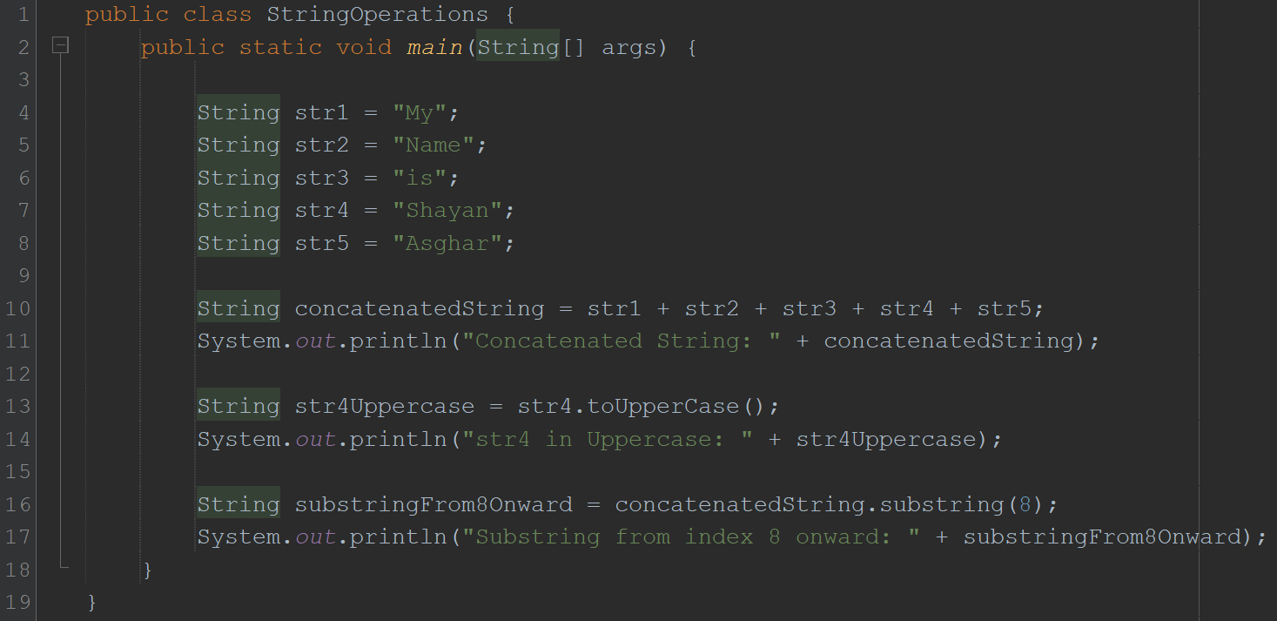

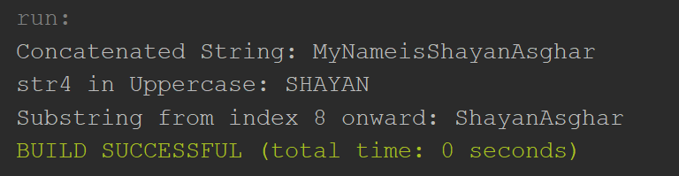

4. You are given two strings word1 and word2. Merge the strings by adding letters in alternating order, starting with word1. If a string is longer than the other, append the additional letters onto the end of the merged string. Return *the merged string.*

**Example:**

**Input:** word1 = "abc", word2 = "pqr"

**Output:** "apbqcr"

**Explanation:** The merged string will be merged as so:

word1: a b c

word2: p q r

merged: a p b q c r

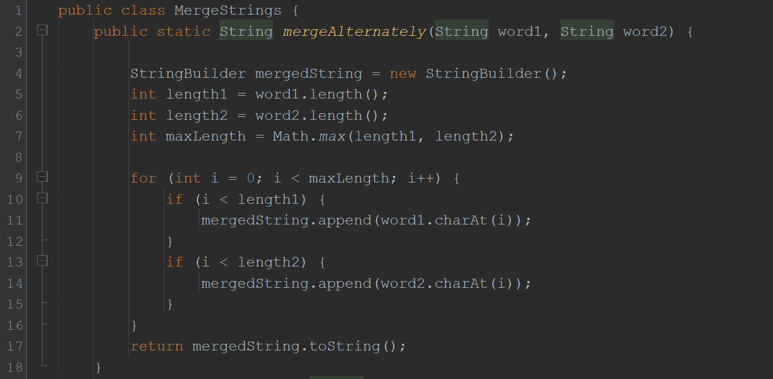

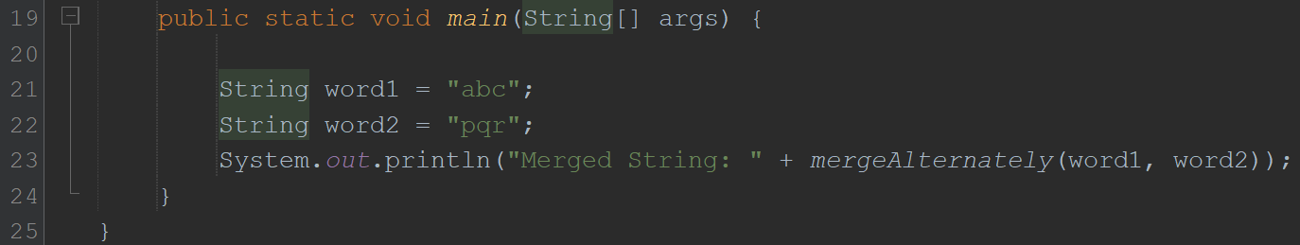

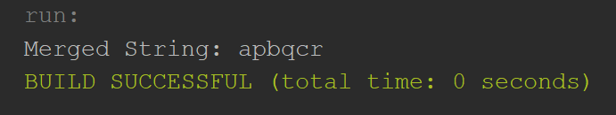

5. Write a Java program to find the minimum and maximum values of Integer**,** Float**,** and Double using the respective wrapper class constants.

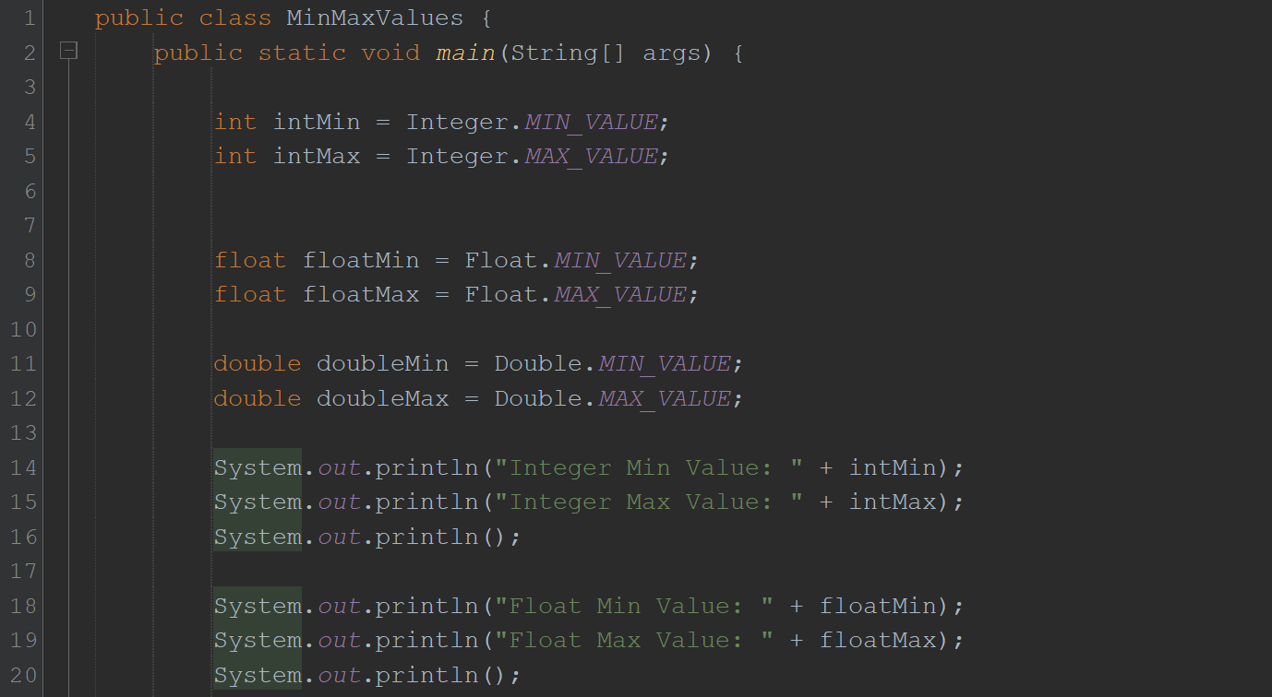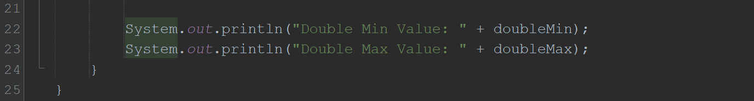

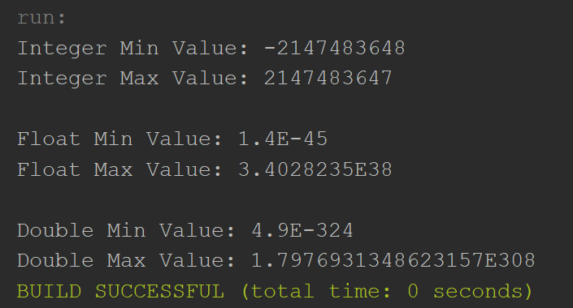

**HOME TASKS**

1. Write a JAVA program to perform Autoboxing and also implement different methods of wrapper class.

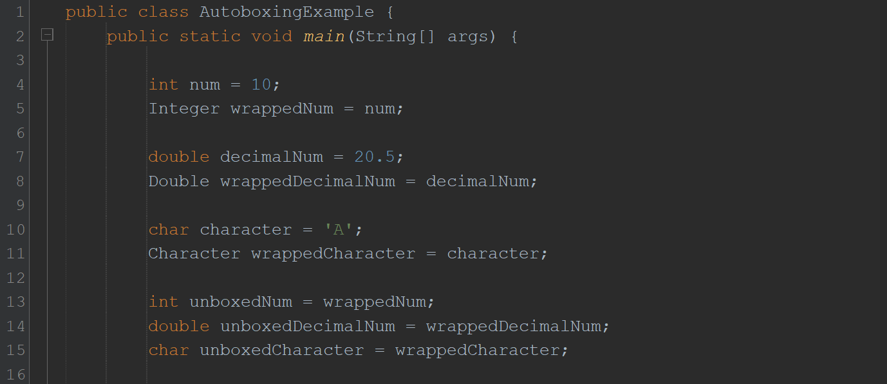

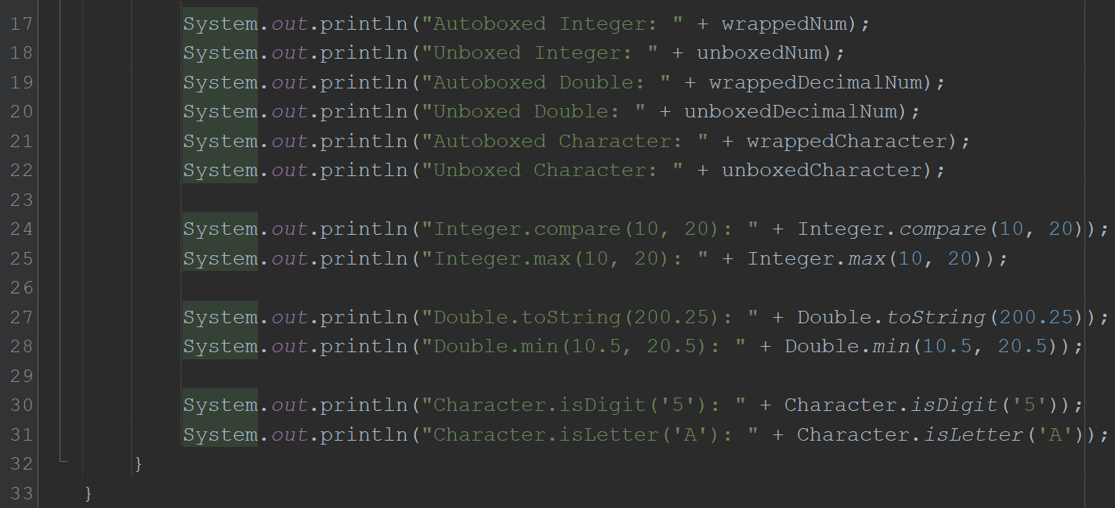

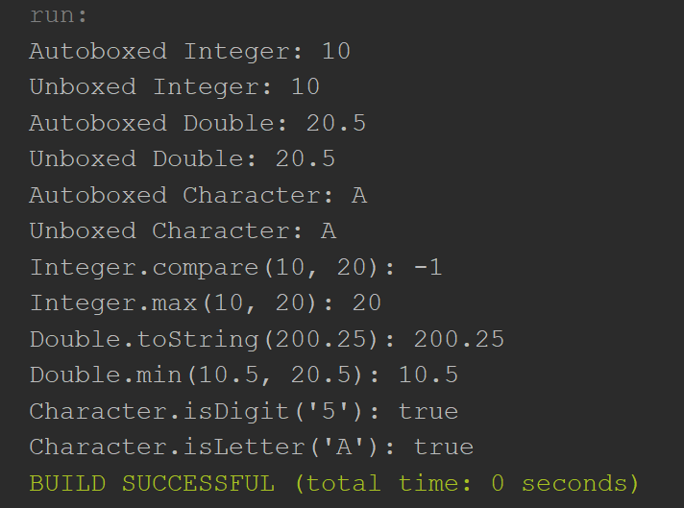

2. Write a Java program to count the number of even and odd digits in a given integer using Autoboxing and Unboxing.

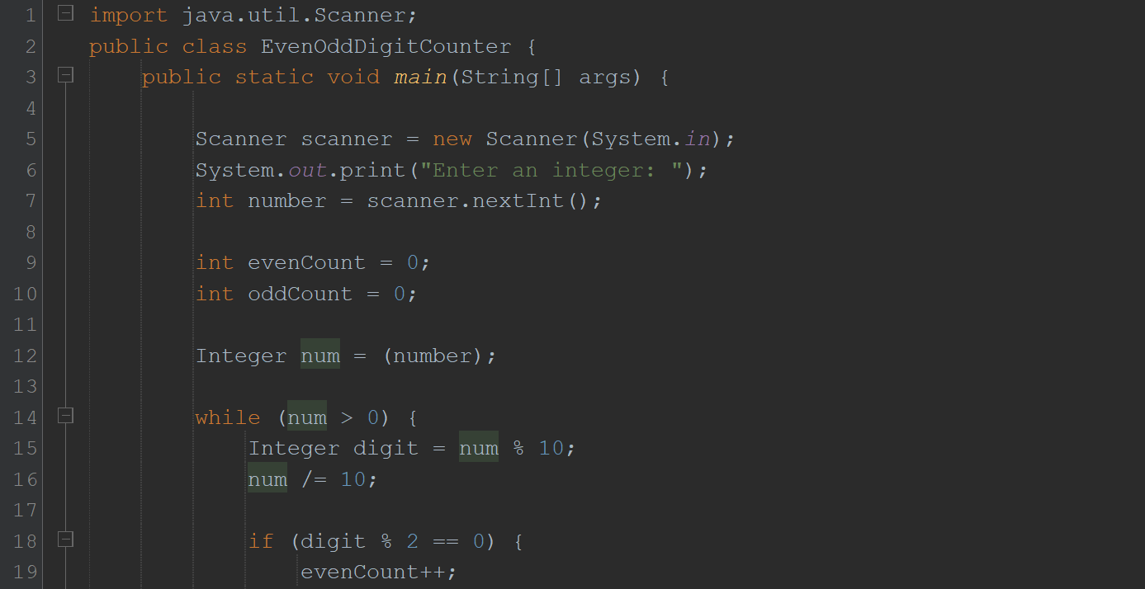

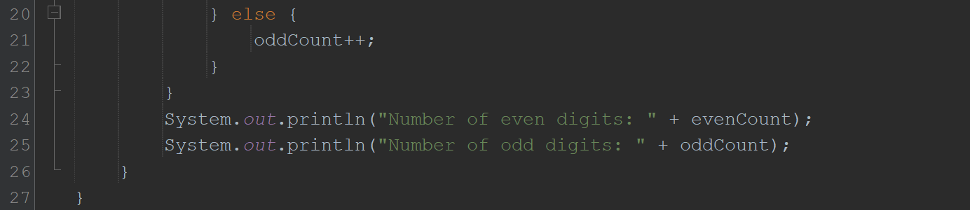

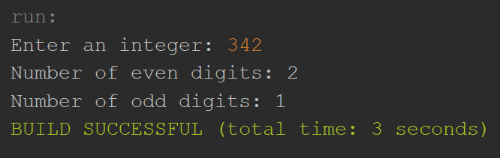

3. Write a Java program to find the absolute value, square root, and power of a number using Math class methods, while utilizing Autoboxing and Wrapper classes**.**

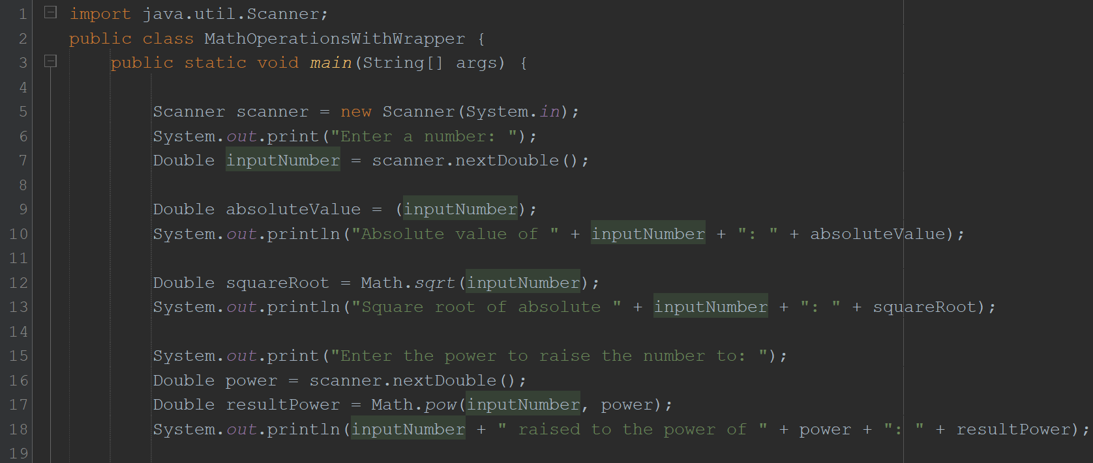

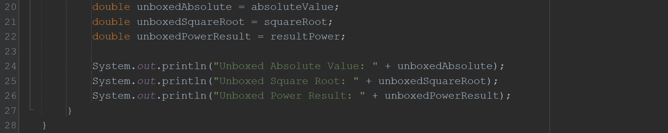

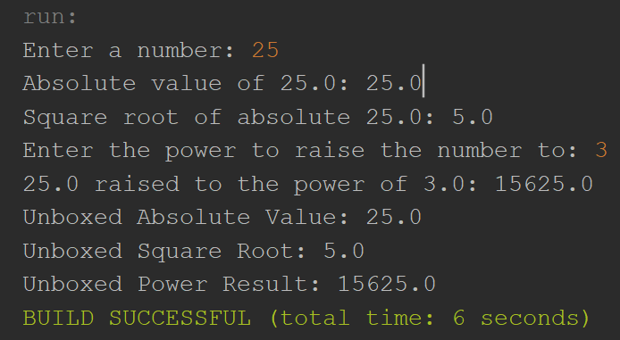

4. Write a Java program to **reverse only the vowels** in a string.

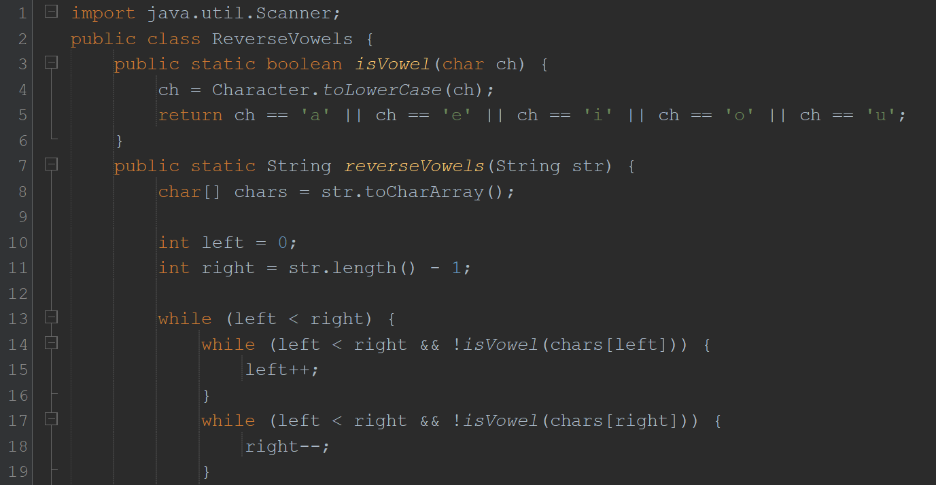

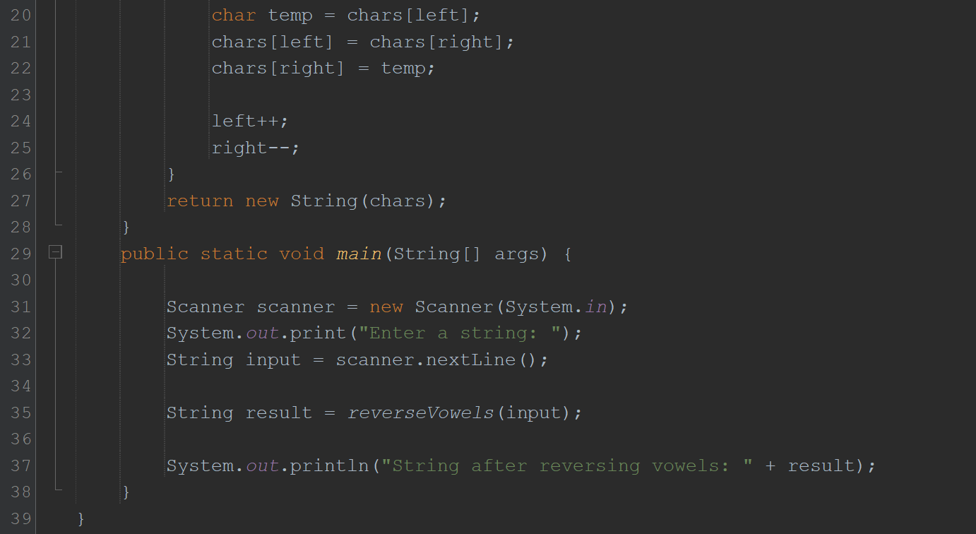

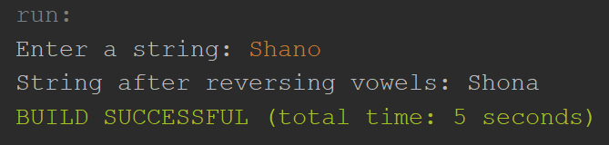

5. Write a Java program to **find the longest word** in a sentence.

